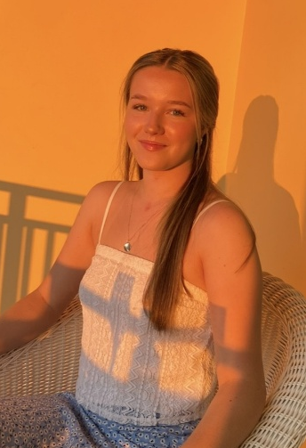
Tara Rose Millar
I am a 21-year-old from Belfast in Northern Ireland. I have completed my history degree at Newcastle University. I am currently living in Ottawa in Canada working as a Barista but will be returning to the UK in December. I am looking for a seasonal job in Tignes, available to start working in mid-January, until the end of the season in April. I am an advanced skier as I have skied with my family in France, Andorra, Austria, Italy and Switzerland since I was 2 years old. I have 5 years of experience in hospitality, including bib-gourmand and Michelin recommended restaurants and I am fully barista trained. I am fluent in English and have basic knowledge of French, able to make some conversation.
Contact: Phone - +44 7482213246. Email – tararosemillar@icloud.com
Skills:
- Strong written and oral communication - Good customer service skills
- Confident and friendly - Advanced Skier
Education:
- 2015-2022 : Sullivan Upper School, 2 A*, 5 A, 3 B at GCSE, A*AB at A level
- 2022-2025: Newcastle University, Bachelor of Arts with First Class Honours in History.
Experience:
2020-2022. The Bay Tree - Café, 118 High Street Holywood, BT189HW.
Worked for two years as a waitress in a café whilst in secondary school. Took orders, served food and drink, cleaned and did stock. Greeted customers and worked on the floor.
2023. Noble - Restaurant, 27 Church Road Holywood, BT189BU.
Worked during the summer in this Michelin awarded Bib Gourmand restaurant. Worked mainly as a back waitress, serving food, clearing tables and taking care of cutlery and glasses.
2024. Fontana - Restaurant, 61 High Street Holywood, BT189AE.
Worked during the summer in this Michelin Guide recommended restaurant. Worked as a waitress taking orders, serving food and drinks, cleaning and greeting customers.
2025. Greens Pizza – Pizzeria, 283-285 Upper Newtownards Road, Belfast BT4 3JH.
Worked during the summer at a local Italian restaurant as a waitress. Serving food, taking orders, making drinks, greeting customers. Given responsibility to open and close.

2025. BBCR Café – Coffee Shop, 511 Lacolle Way, Ottawa, Ontario, K4A 5B6
Worked for 3 months in Canada as a full-time barista in a Café. Made and served coffee, took orders, cleaned, given responsibility to open and close.

